SUPPLIES NEEDED:
Clear Cedar 2x4s cut to 14” in length
Marine glue
Cabinet screws 8x2.4”
Waterproof wood filler
Scripture “Scrolls” in size 2 print
Varathane or Deft Spray to coat the Scripture Scrolls before they are rolled
3x3” plywood ¾ “ thick (cut in 3x3” squares to go on the top for a pounding pad

TOOLS NEEDED:
Chop saw
Table saw
Router
Jig Guide (Used to create the points on the stakes
Planer
Belt Sander
Drill
Wood clamps capable of 4x4”

- Gather supplies
- Cedar to be cut in 14” lengths
- Scripture prepared ahead is covered with varathane or Deft and allowed to dry, then rolled into a half inch scroll. May use a rubber band
- Router the hole in the center of the 2x4 ½ “ deep and 5” long at an exact location (above point)
This should be done on every 2x4 in an exact spot so they match when put together.
- Prayer and anointing oil goes into the router hole. (We used cedar anointing (releases the knowledge of God and Frankincense)
- Paint both sides of the routered side with marine glue
- Place the scroll in the routered hole in the center of the stake and immediately put the two sides of marine glue together so the routered hole matches on both sides.
- Drill 3 small holes deep to reach the other side of the 2x4 and screw 3 stainless screws into the cedar. Then clamp.
- Await the required set time (24 hours) and remove the screws.
- Using the jig, (Guide to saw an exact point), Saw a four sided point.
- Use planer to smooth the stake and sander to bring to the desired smoothness
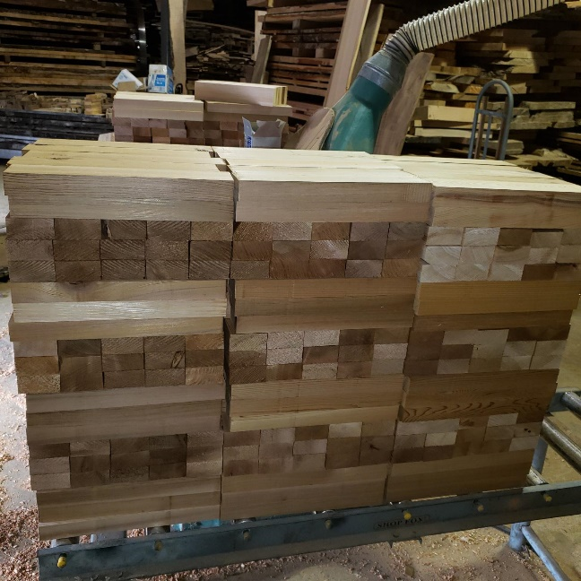
- Our Cedar comes from Cyril Jacob
    - Old growth cedar reclaimed from the Tillamook Burn
    - Most is clear cedar, fine grained and has already been on the ground 100 years.

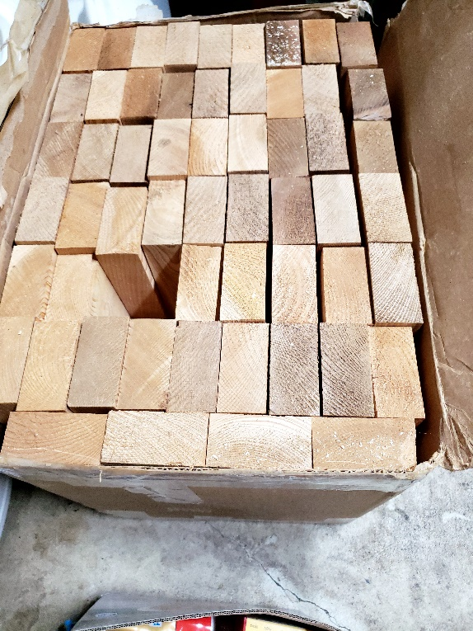
Cyril cuts the cedar to specs – 2x4 x 14” and sends them boxed
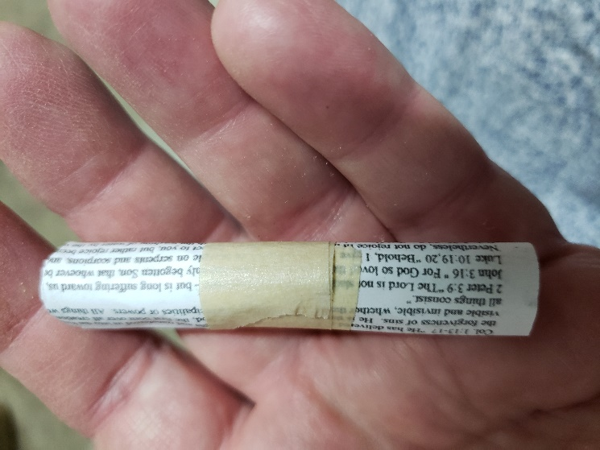
- We took 70 Redemptive scriptures and shrank them into size 2 to fit on half of a 8x11 sheet of paper, front and back.
- Sprayed them with Varathane or Deft and allowed them to dry
- Rolled them into a tiny scroll
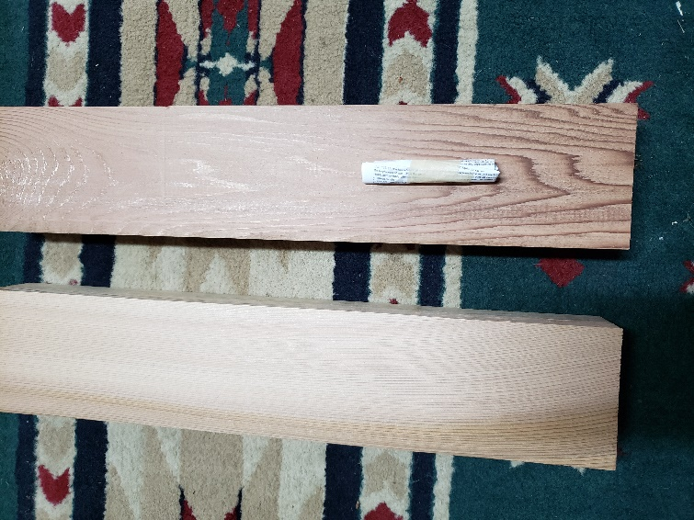
- A routered hole was placed on each side of the wood approximately where the “scroll” is. The holes have to be exact on both pieces of wood and fit the length of your scroll with no pressure, so it doesn’t leak.
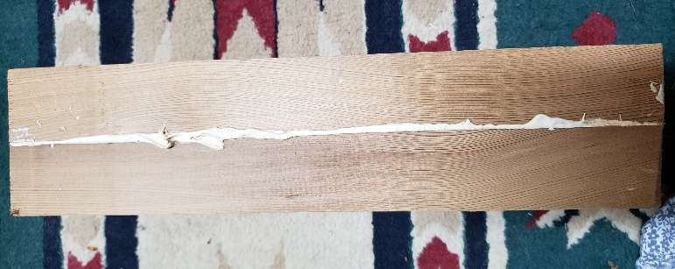
- Both sides of the 2x4, are marine glued, scroll placed in the routered hole,
- Anointing oil applied inside the hole
- Both sides put together

- Holes are drilled
- 6 screws placed
- Marine glue dries per label
- Wood clamps may be used
- Remove screws when done- important to protect saw and also makes stake unfindable with a metal detector.
- Put wood filler in the holes

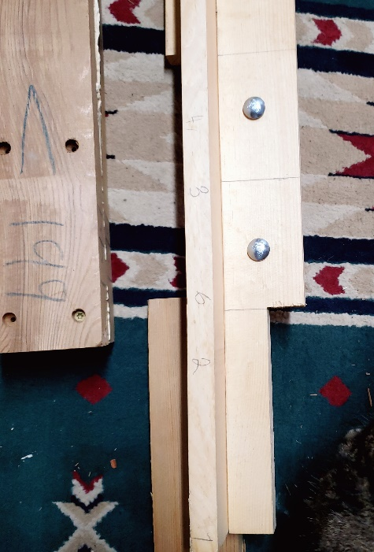
This is two angles of one jig. A jig is something that holds the stake in place while it is being sawed exactly the same for the point.

I am not sure exactly how they work but a carpenter would.
With complete precision, saw the point onto the end of the glued 2x4s

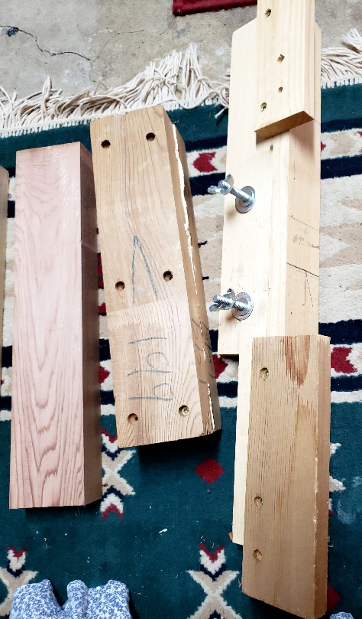

- A ¾” pounding pad should be tacked or glued on the top of each stake to prevent splitting when the stake is pounded
- We numbered our stakes to track locations of where they were placed

Finished cedar stake 13” long
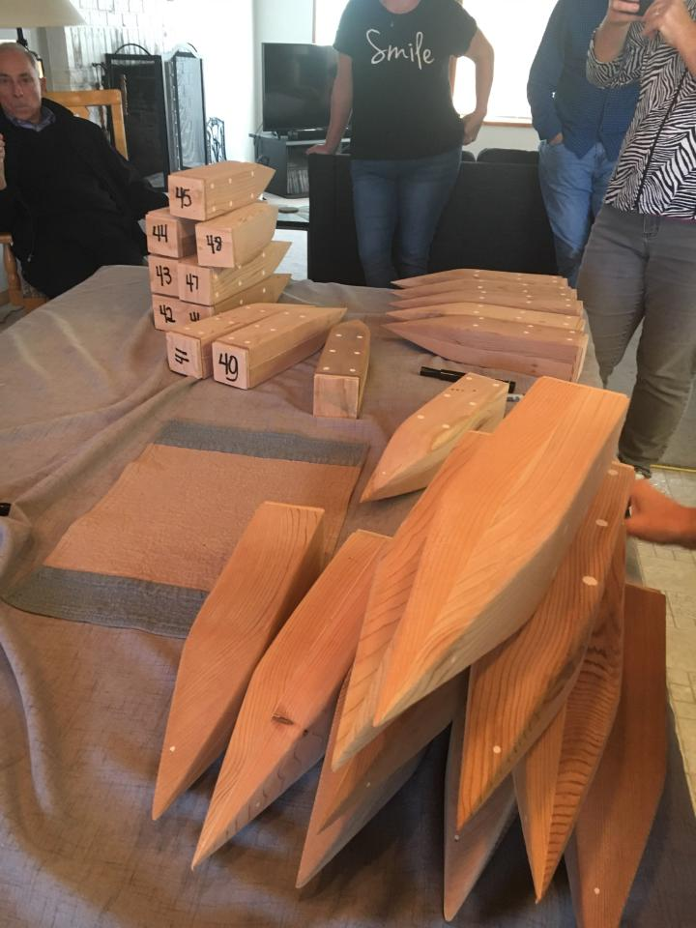
- The finished cedar stakes are labeled and prayed over for their intended purpose with declarations of love, healing, repentance, anointed again with oil and delivered to their intended location.
- The man, Tim Turner, who build all of the original stakes has passed into eternity. Every part from the cutting of the cedar, milling it and building the stakes has been done by Christians who understood the gravity and importance of declaring God’s territory in LOVE.
